nMethodology

A] Dataset Preparation
The dataset consists of labeled breast cancer images stored in a directory structure (dataset). Each subfolder represents a class label, such as benign and malignant. These images serve as input to the training, validation, and testing processes.
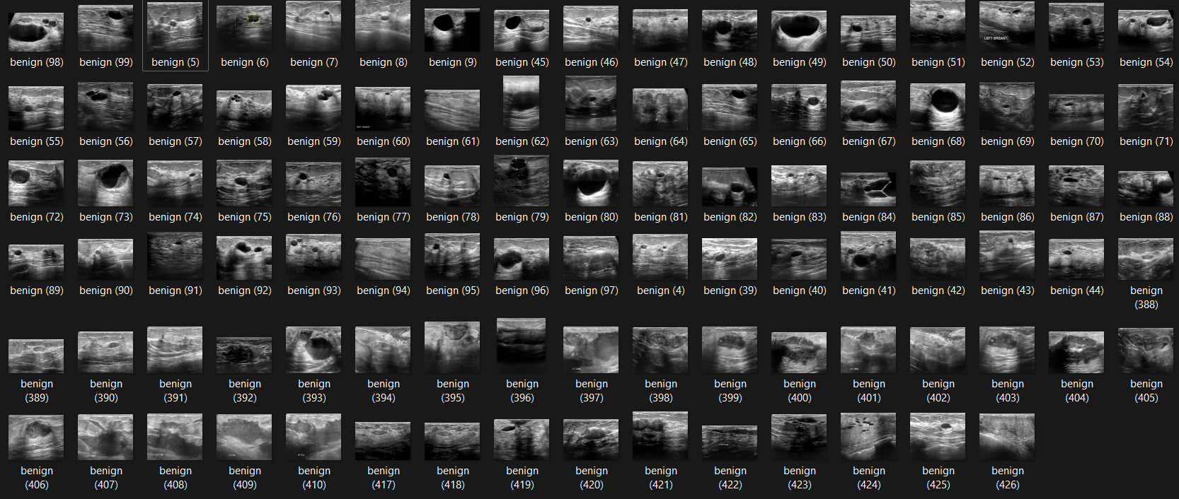
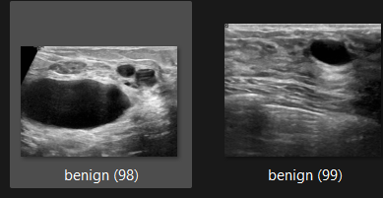
Preprocessing Steps:
1] Resizing Images:
All images were resized to 224×224224 \times 224 pixels to match the input size required by the MobileNet architecture. This ensures uniformity in the data and compatibility with the model.
2] Normalization:
i] Pixel intensity values were normalized to a range of [0,1][0, 1], ensuring stable model training:
ii] This step standardizes the input data, reducing potential biases caused by differing image intensities.
3] Data Augmentation:
To improve the model's generalization and robustness to variations, augmentation techniques were applied dynamically during training. These included:
i] Random Horizontal Flipping: Simulating natural variations in image orientation.
ii] Random Cropping: Adjusting margins of the image.
iii] Brightness Adjustments: Enhancing or reducing image brightness by ±10%.
iv] Scaling: Randomly enlarging or shrinking the image by ±10%.
4] Dataset Splitting:
  - The dataset was split into three subsets:
    - Training Set (80%): Used for training the model.
    - Validation Set (10%): Used to monitor performance during training and prevent overfitting.
    - Test Set (10%): Used for final evaluation of the model’s performance.
5] Class Balancing:
  - Breast cancer datasets often have imbalanced class distributions. To address this, underrepresented classes were augmented further to ensure equitable representation during training. This step prevents the model from favoring overrepresented classes.

B] Model Training Workflow
Architecture Selection:
The MobileNet model pre-trained on ImageNet, was chosen for its balance of computational efficiency and accuracy. This makes it suitable for resource-constrained environments and deployment scenarios.
Steps in Training Workflow:
1] Feature Extraction (Bottleneck Caching):
i] Bottleneck features, which are outputs from the penultimate layer of MobileNet, were extracted and cached for each image. These features represent high-level information about the images and significantly reduce computational overhead during retraining.
ii]Caching these features also ensures that subsequent training iterations are faster and more efficient.
2] Adding a Fully Connected Layer:
A fully connected softmax layer was added to adapt the pre-trained model to the specific task of breast cancer classification.
  - Weights: Initialized with a truncated normal distribution to ensure convergence.
  - Biases: Initialized to zero.
  - Softmax Activation:
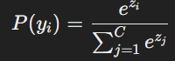
where ziz_i is the logit for class ii, and CC is the total number of classes (2 in this case: benign and malignant).
3] Optimization and Loss Function:
  - Cross-Entropy Loss:
The model was trained to minimize cross-entropy loss, which is defined as:
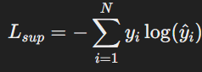
  - Optimizer:
Stochastic Gradient Descent (SGD) was used to update weights iteratively based on the loss gradient. The learning rate was set to 0.010.01 to balance convergence speed and stability.
4] Training Configuration:
  - Batch Size: 100 images per batch.
  - Training Steps: 6000, sufficient for convergence.
  - Validation Frequency: The model was evaluated on the validation set every 10 steps to monitor performance and detect potential overfitting.

C] Evaluation Metrics and Results
The model’s performance was evaluated using several metrics on the test set:
- Accuracy:
Measures the overall percentage of correctly classified images:
  - Training Accuracy: 95.1%
  - Validation Accuracy: 94.5%
  - Test Accuracy: 94.9%
- Precision, Recall, and F1-Score:
  - Precision: Proportion of true positive predictions among all positive predictions:
    - Result: 97.04%
  - Recall: Proportion of true positive predictions among all actual positives:
    - Result: 97.62%
  - F1-Score: Harmonic mean of precision and recall:
    - Result: 97.33%
- ROC-AUC Score:
The area under the ROC curve indicates the model’s ability to discriminate between classes:
  - Result: 98.2%98.2\%.
D] DEPLOYMENT
The web application was developed using Flask to facilitate the upload of images for breast cancer classification. HTML templates were utilized to create user-friendly interfaces for image uploads and the display of predictions. The backend of the application loads the trained machine learning model, processes the uploaded images by resizing and normalizing pixel values, and performs inference through the model. The system includes routes for the home page and the image upload page. For production deployment, the application is hosted using Gunicorn. The model was evaluated to achieve an accuracy of 94.9%, maintaining its performance during deployment and successfully classifying images. Misclassified instances are logged for ongoing model refinement, particularly in handling challenging scenarios such as low-quality images.

